**Advanced Programming in Java**

**Creating Empty Java Projects with JCreator**

In this course we will be creating projects for each program that we write.

1. Create a folder on your desktop called MyJava
2. Start JCreator (we are using version 4.5)
3. Select File|New|Project from the menu which will start the Project Wizard.

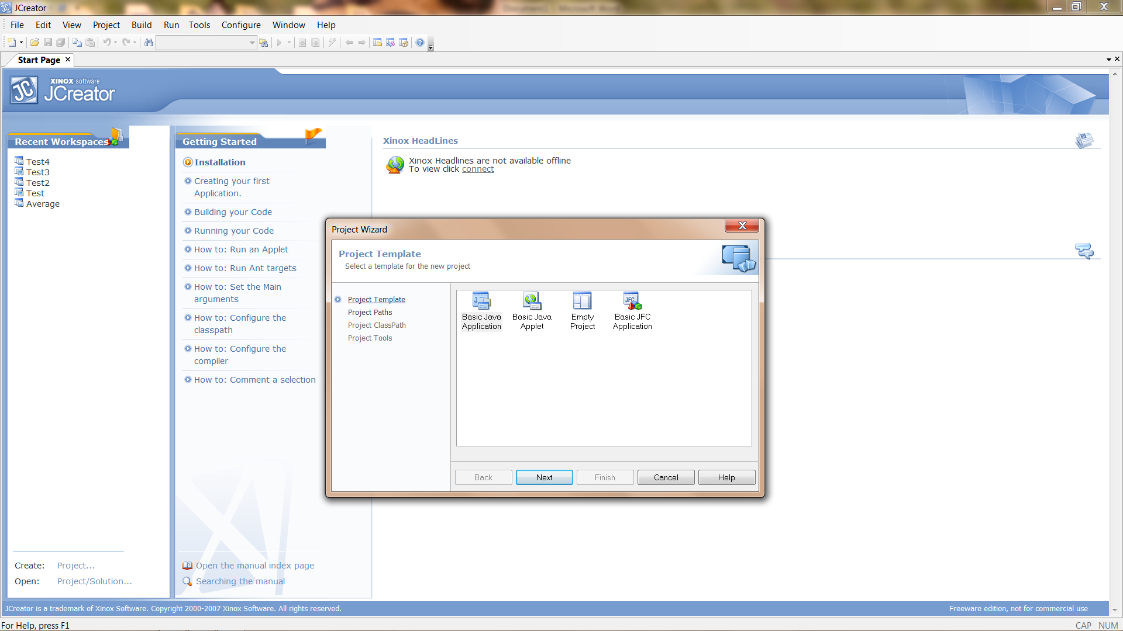

1. Select Empty Project and click Next.

Enter the Project name and navigate to the MyJava folder on your desktop. Add a folder (inside MyJava) for your project. I used Hello.

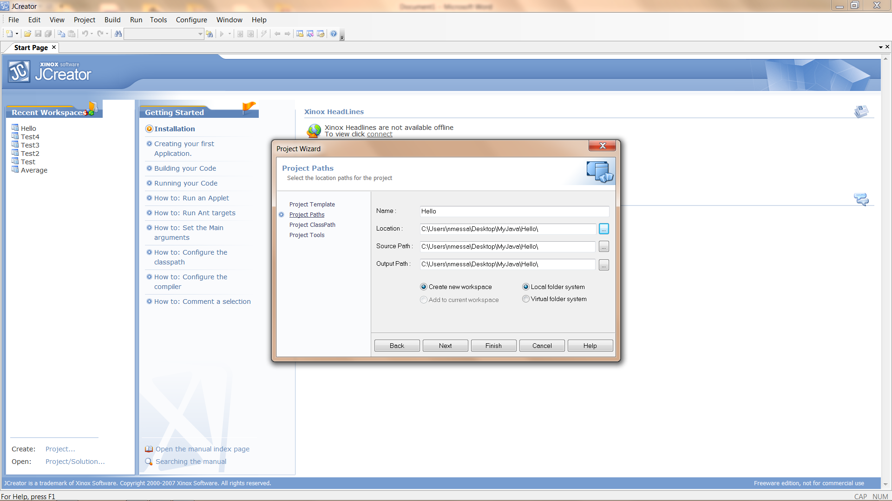

1. Click Next

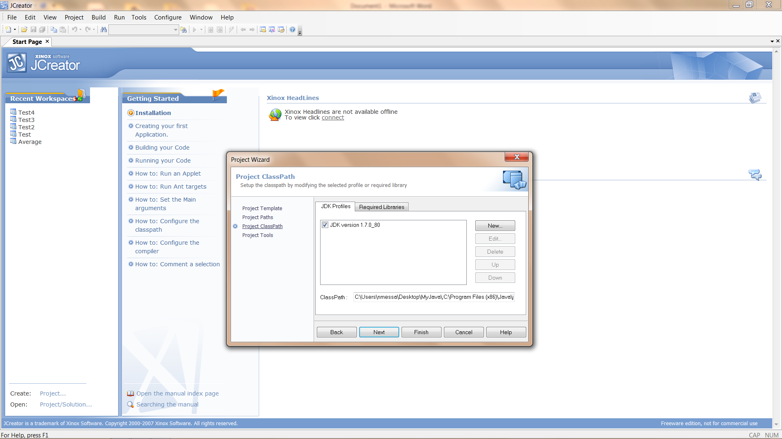

1. Click Next

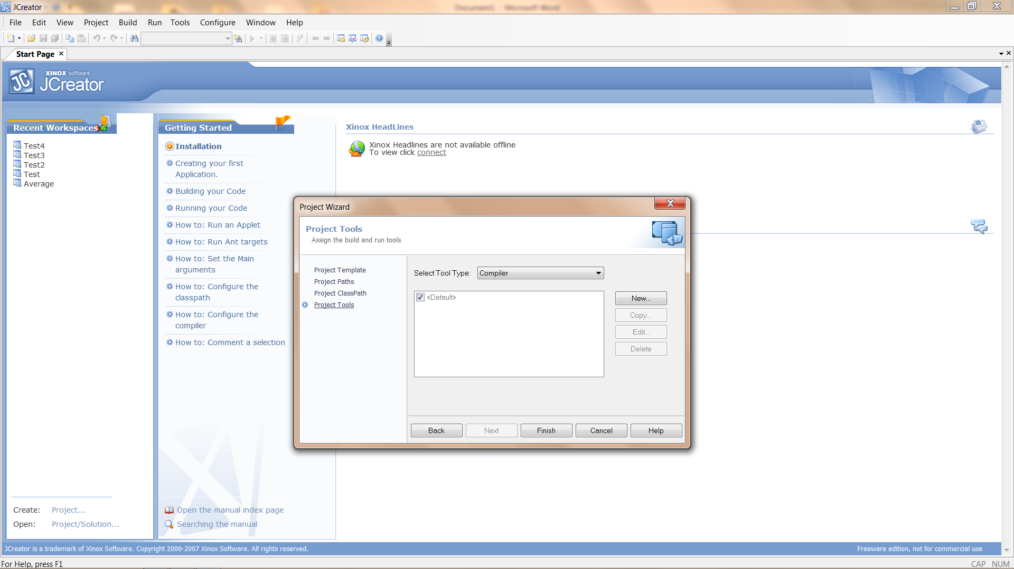

1. Click Finish

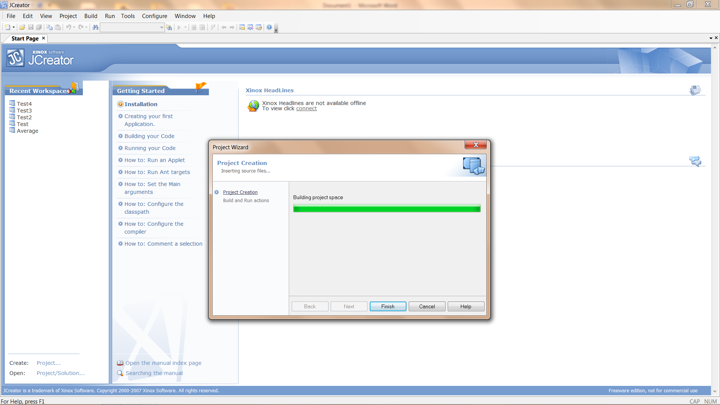

1. When the project has completed building, click Finish

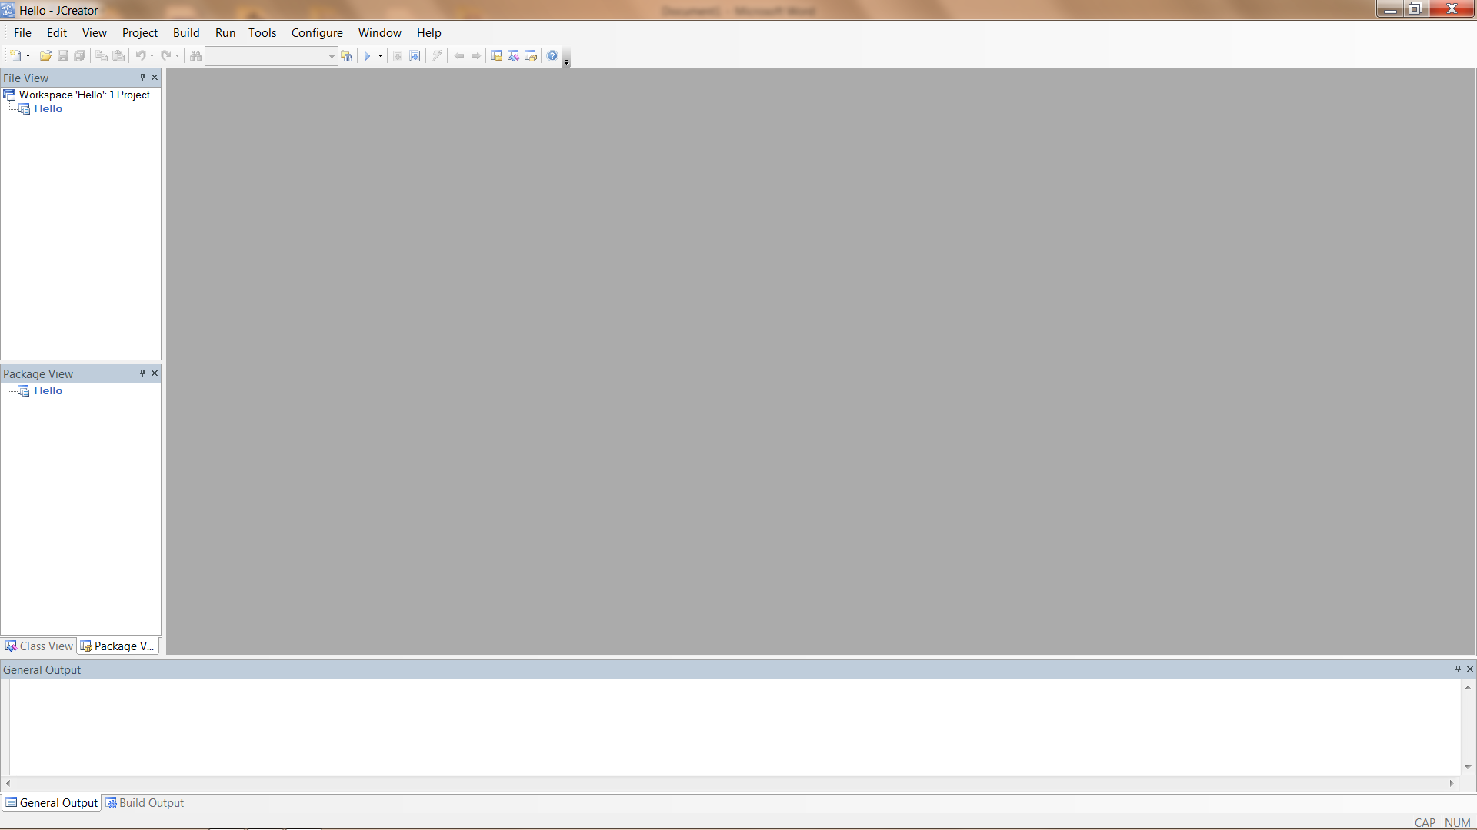

At this point we have an Empty Project. If you look inside the Hello folder (inside the MyJava folder) you will see 3 files (Hello.jcp, Hello.jcu, and Hello.jcw).

1. We will now add a file to our project by right-clicking on the project name and then Add|New File. This will open the File Wizard.

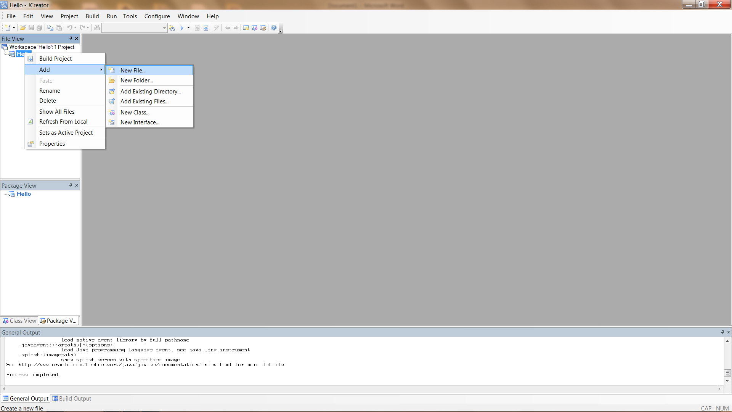

1. Select Main class and Next.

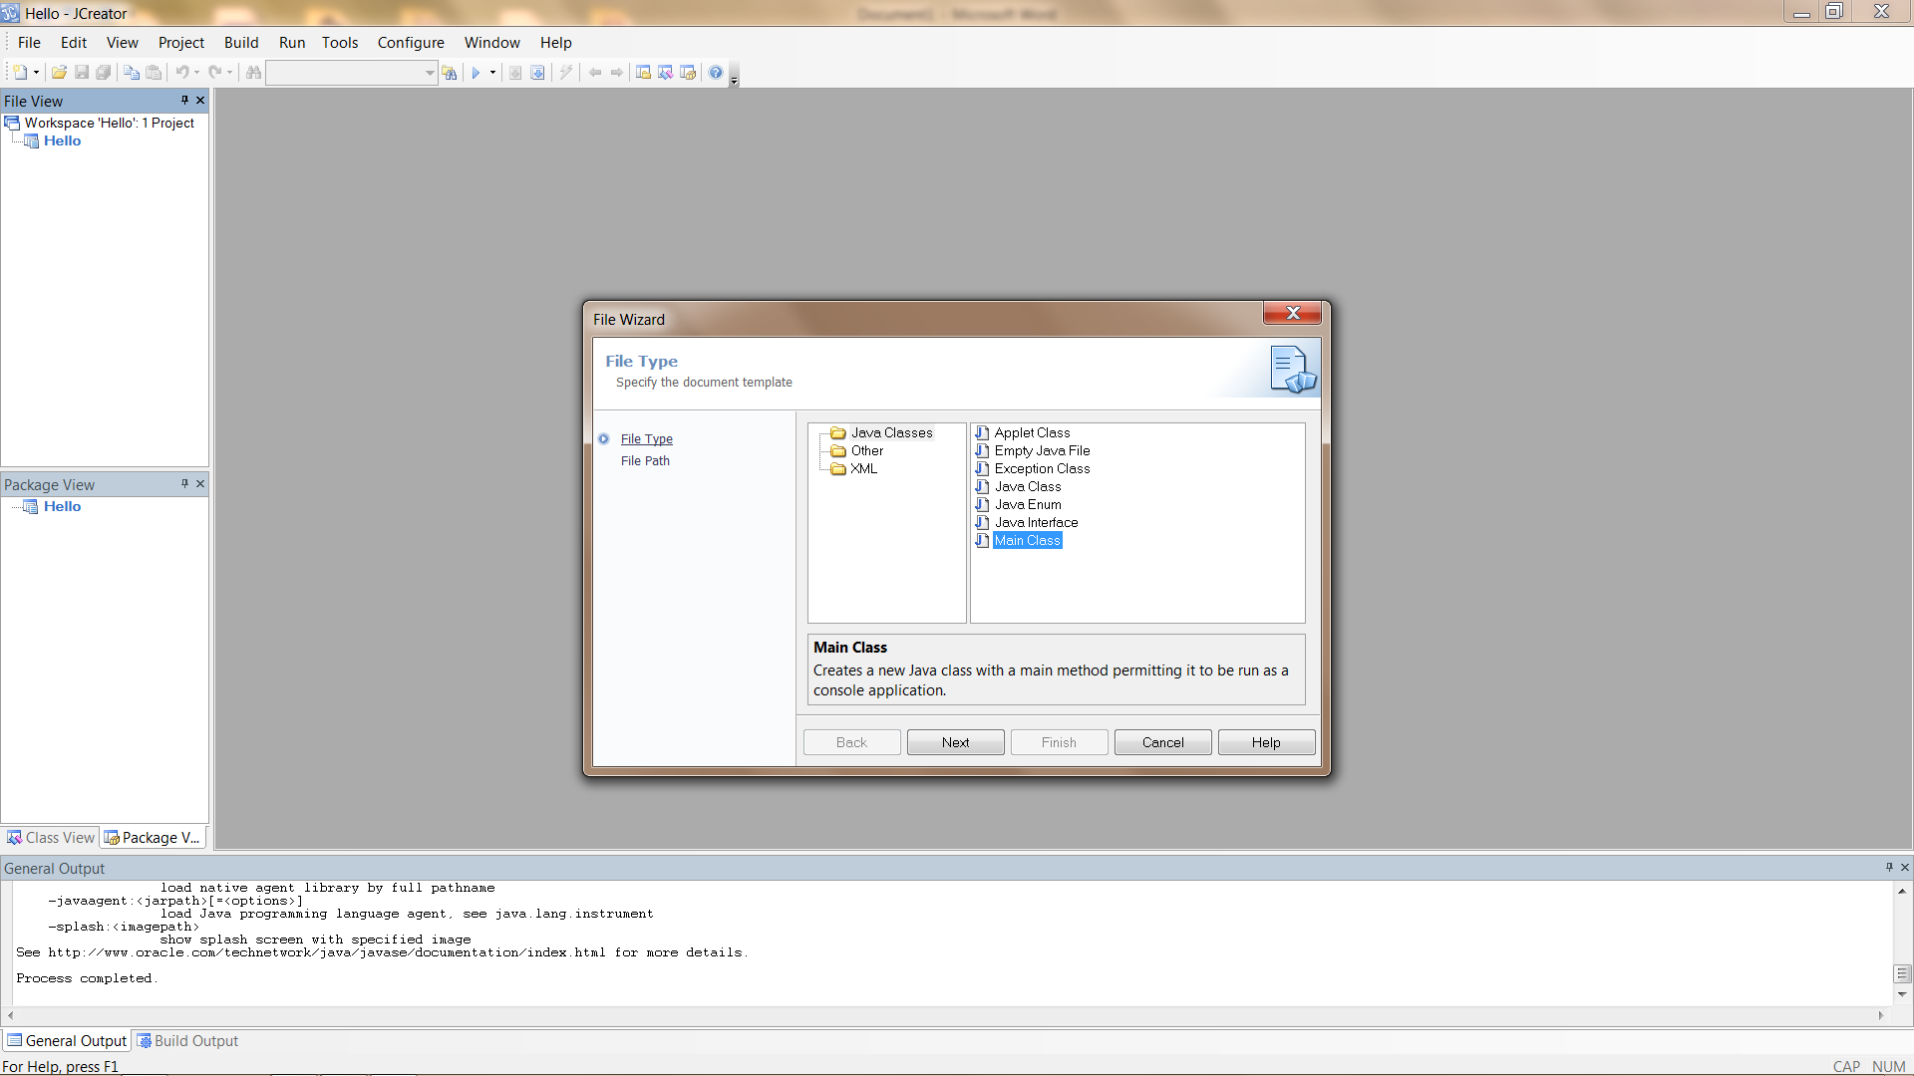

1. Give it a name of Hello.java and click Finish.

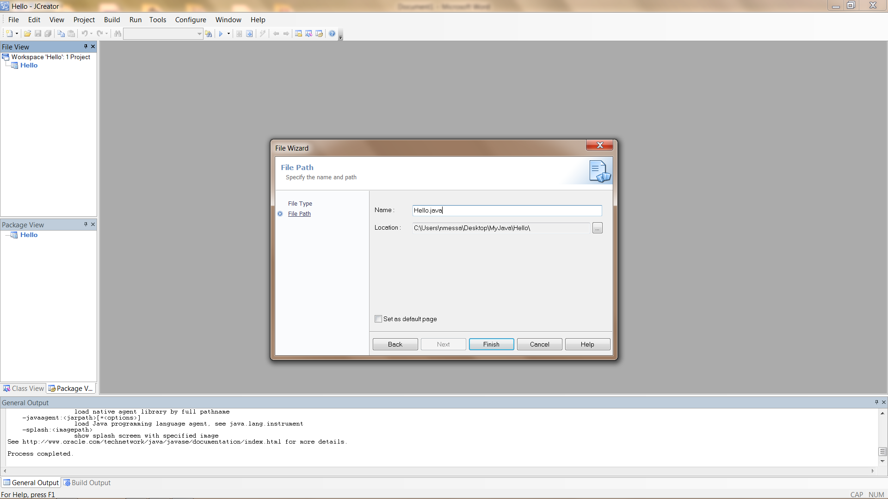

1. You will now have a source file which contains a class Hello. The class Hello contains a constructor method and a main method.

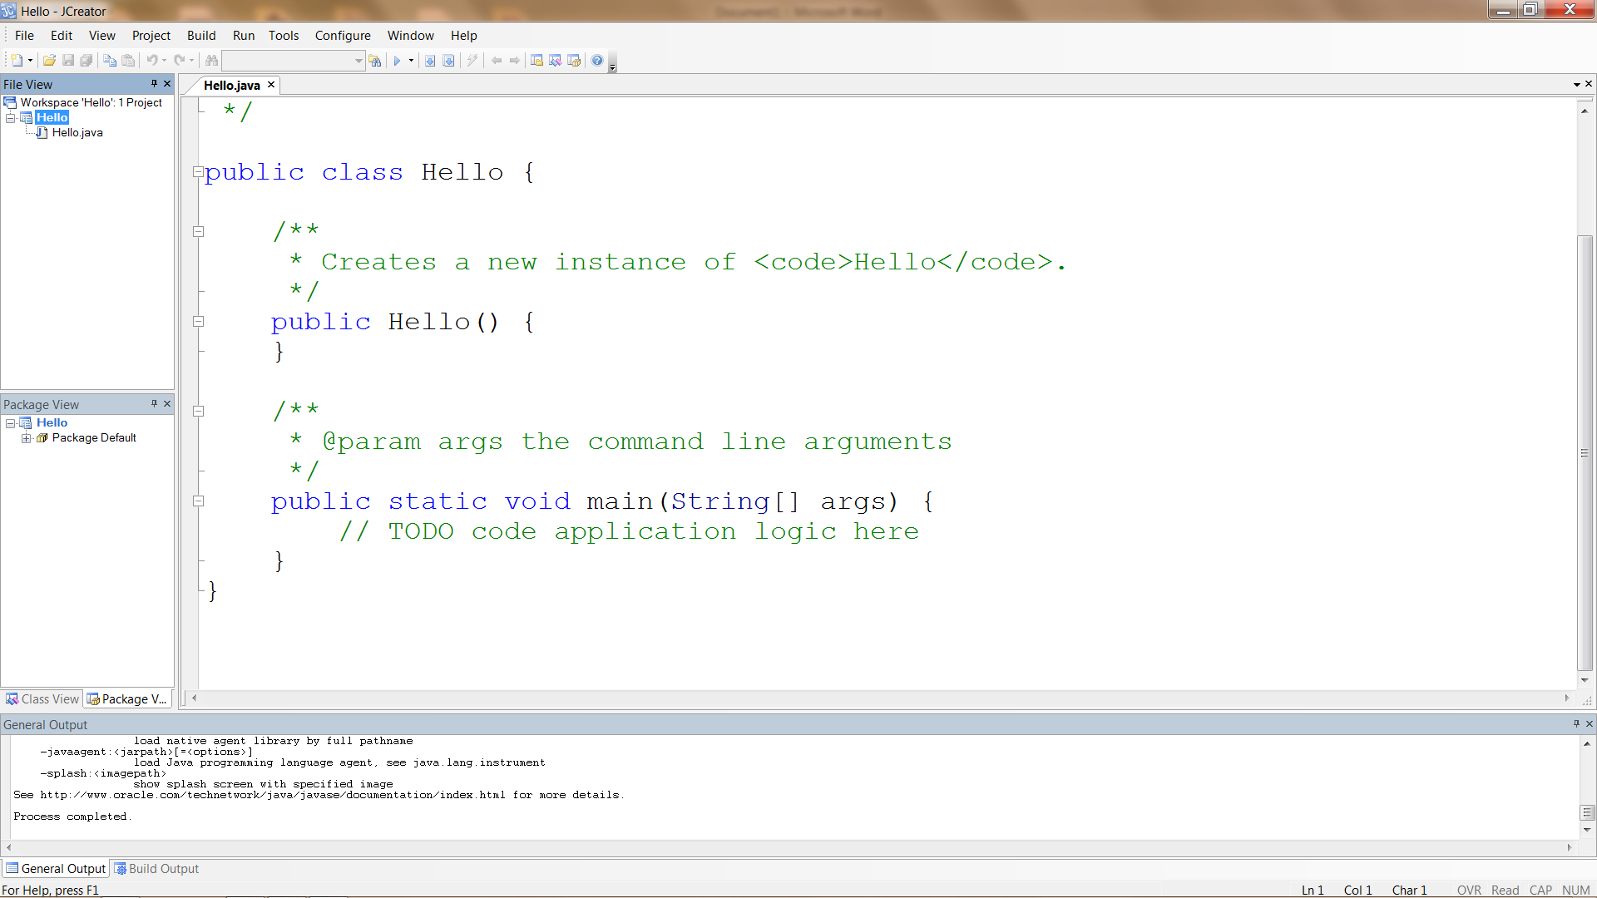

1. Click on the Run Project button and you should get a Process Complete message

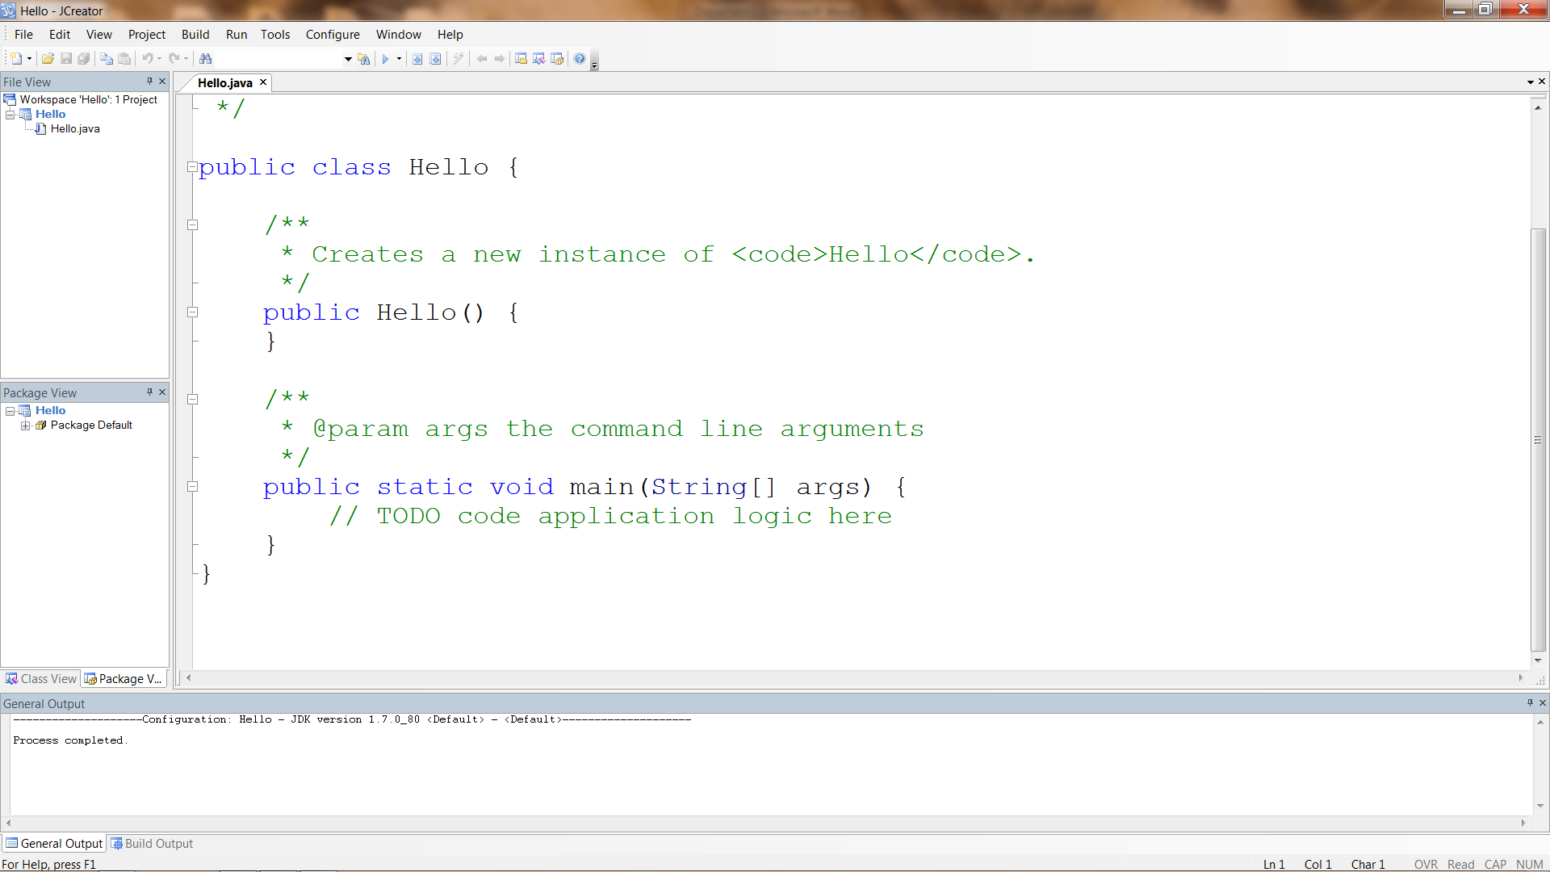

1. Now we will add code to the main method to print “Hello World!!!” to the console. Don’t forget the semicolon at the end of the line.

System.out.println("Hello World!!!");

After entering code, hit the Run Project button and you should see the “Hello World!!!” message in your console.

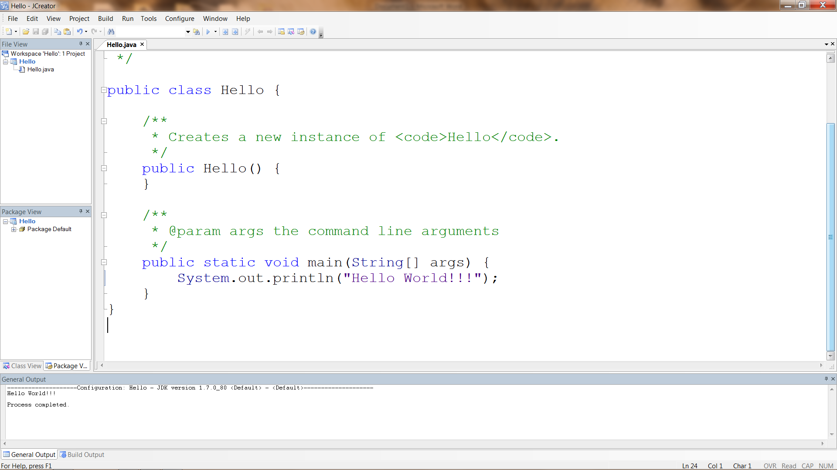

1. Now take a look in the MyJava\Hello folder. You should see Hello.java and Hello.class.

